K.E of gas molecules with the increase in temperature
A. decreases
B. increases
C. remain same
D. none of them
ANSWER: B
100$℃$ is equal to
A. 273K
B. 373K
C. 300K
D. 400K
ANSWER: B
If the volume is doubled at a constant temperature, the pressure is
A. Doubled
B. Reduced to one half
C. Increase 4 times
D. none
ANSWER: B
V α T at constant pressure is the statement of
A. Boyle’s law
B. Avogadro’s law
C. Graham’s Law
D. none
ANSWER: D
V α T keeping constant is
A. Average K.E
B. P.E
C. Pressure
D. All of them
ANSWER: C
The ratio of volume to temperature is always
A. Greater than 1
B. Less than 1
C. Constant
D. None
ANSWER: B
The graph of Charles’s law gives
A. straight line
B. parabolic curve
C. hyperbolic curve
D. all the them
ANSWER: A
If the line of the graph obtained from Charles’s law is extra plotted it intersects the temperature axis at
A. 273$℃$
B. -273$℃$
C. 273.16$℃$
D. -273.16$℃$
ANSWER: D
Theoretically, the volume of gas becomes 0 at
A. -273.16$℃$
B. -273$℃$
C. 0K
D. Both A&C
ANSWER: D
All substances (except water) upon heating
A. Contract
B. Expand
C. Decompose
D. none
ANSWER: B
The body temperature of a healthy person is
A. 97.6 ⁰F
B. 96.8 ⁰F
C. 98.4 ⁰F
D. 98.6 ⁰F
ANSWER: B
At what temperature, do both Fahrenheit and Centigrade scales coincide?
A. 32 $℃$
B. -40 $℃$
C. -30 $℃$
D. 40 $℃$
ANSWER: B
Which of the following graph represents Charles’s Law?
A. 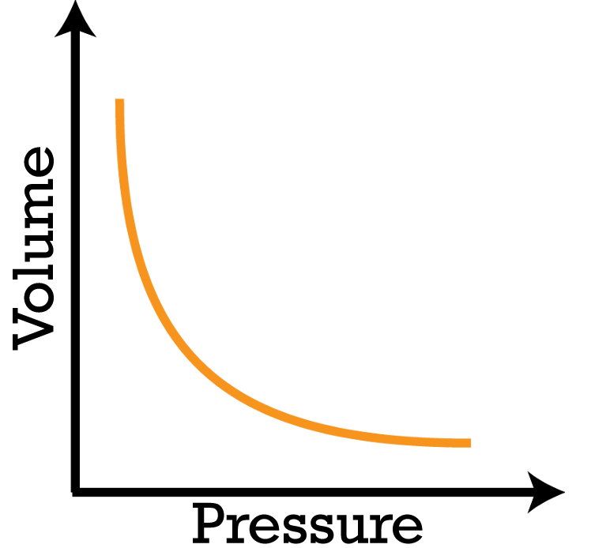
B. 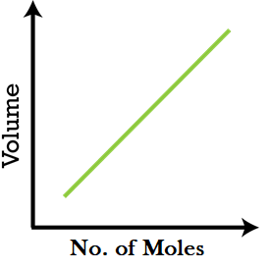
C. 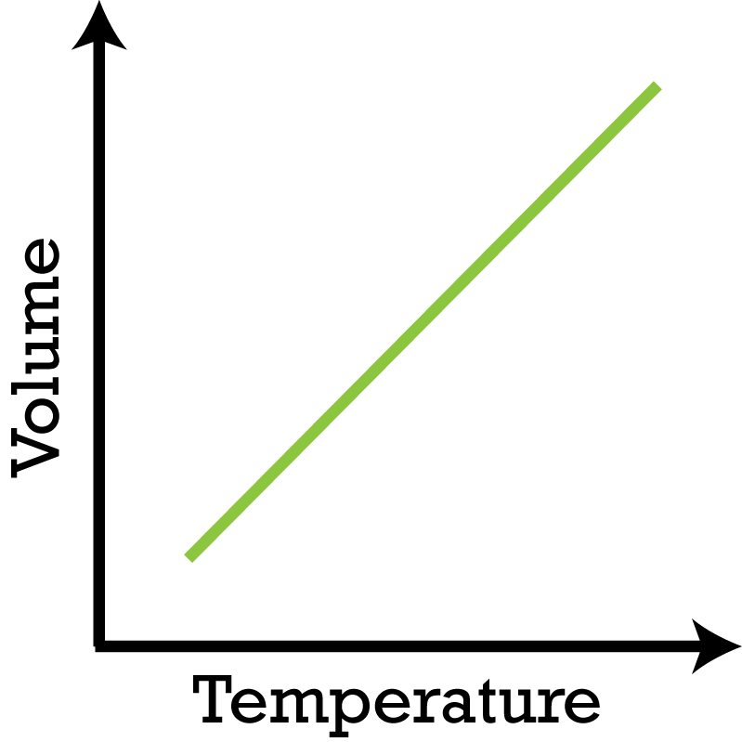
D. None of these
ANSWER: C
The constant quantity(s) in Charles’s Law is (are):
A: Temperature
B: Volume
C: Pressure and Mass of gas
D: Temperature and Mass of gas
ANSWER: C
The nature of the V-t (t in Celsius scale) graph in Charles’s law is-
A: Straight line
B: Circle
C: Parabola
D: Hyperbola
ANSWER: A

